Title: Using genetic parentage analysis to inform spring Chinook salmon (*Oncorhynchus tshawytscha*) reintroductions above high-head dams in the Upper Willamette River, Oregon.

Authors*: Andrew Black 1,†, Nick Sard 2, Marc Johnson 3,4, Cameron Sharpe 4, and Kathleen O’Malley 1

* AUTHORSHIP ORDER NOT DETERMINED

1 Coastal Oregon Marine Experiment Station, Hatfield Marine Science Center, Department of Fisheries and Wildlife, Oregon State University, 2030 SE Marine Science Drive, Newport, Oregon 97365

2 Fisheries and Wildlife Department, Michigan State University, 480 Wilson Rd, East Lansing, MI 48824

3 Oregon State University, Department of Fisheries and Wildlife, 2820 SW Campus Way, Corvallis, Oregon 97331, U.S.A

4 Department of Fish and Wildlife, Upper Willamette Research, Monitoring, and Evaluation, Corvallis Research Laboratory, 28655 Highway 34, Corvallis, OR 97333, USA.

† Corresponding author:Andrew N. Black

Coastal Oregon Marine Experimental Station

Hatfield Marine Science Center

2030 SE Marine Science Drive

Newport, OR, 97365

*Email:* [blackand@oregonstate.edu](mailto:anb410@lehigh.edu)

*Phone*: 541-867-0230

*Fax*: 541-867-0345

**Abstract**

INSERT

**Introduction**

Here, we compile nearly a decade worth of data collected from three above-dam populations of spring Chinook salmon to i) provide a resource for others looking to implement a genetic pedigree in salmonid conservation and ii) evaluate long-term patterns within / between populations to provide insight into the sustainability of these threatened populations.

Chinook salmon are an anadromous, semelparous fish native to the North Pacific Ocean and its tributaries. Upper Willamette River (UWR) spring Chinook salmon are currently listed as threatened under the U.S. Endangered Species Act (NMFS 2005, 2008).

Materials and methods

The current study focuses on the reintroduction efforts intended to contribute to the recovery of spring Chinook salmon (*Oncorhynchus tshawytscha*) populations above three high-head dams (Detroit, Foster, and Cougar) in the Upper Willamette River, Oregon (Figure 1). We begin with a brief overview of each impounded river (North Santiam, South Santiam, and South Fork McKenzie) by describing the system; i.e. dam(s), fish hatchery, trap and haul facility, the primary management strategy, and exceptions made to these strategies over the past several decades. Due to the extensive supplementation of hatchery reared salmon within these systems, adult returns are either marked (adipose fin removed) hatchery-origin (HOR) or unmarked (adipose tissue intact), presumed natural-origin (NOR) salmon. However, we note that a substantial proportion (mean = 21%; range: min – max = 10 - 31%) of unmarked HOR salmon are unintentionally reintroduced above these dams, as revealed by otoliths revealing thermal marks indicative of hatchery practices on the South Santiam River (Supplemental Table 1).

*South Santiam River – Foster Dam*

The South Santiam (SS) River is impounded by two large dams, Foster (38m-tall) and Green Peter (100m-tall), which collectively impede volitional access to ~85% of the historical spawning habitat for spring Chinook salmon (Figure 1a; ODFW and NMFS, 2011). Currently, habitat above Green Peter Dam is not utilized for re-establishing a sustainable salmon population, with all recovery efforts directed at habitat located above Foster Dam (44.4165, -122.6693). As a flood control measure, dam operations were initiated in 1968, which coincided with the establishment of a salmon hatchery situated below Foster Dam. The South Santiam Hatchery has produced juveniles for release in the SS River (following captive-rearing for one year) since operations began in the 1960s.

In 1996, an attempt to re-establish a naturally spawning population of spring Chinook above Foster Dam was initiated by reintroducing HOR salmon surplus to the annual broodstock requirements. Following the apparent success of this strategy, in 2008 management began supplementing HOR salmon with unmarked (adipose fin intact) NOR salmon captured at a trap and haul facility located below Foster Dam. Adult recruits travel up a fish ladder at the base of Foster Dam, where they are kept in holding ponds prior to sorting and loading them into a transportation truck for release into habitat above Foster Dam. Starting in 2009, only NOR Chinook salmon have been reintroduced above Foster Dam (Figure 1). Additionally, beginning in 2011, otoliths were extracted from above-dam carcass samples and examined by Washington Department of Fish and Wildlife for hatchery-induced thermal marks, which allow for an estimation of the percent unmarked HOR salmon recruiting back to the river. The genetic profiles of above-dam carcasses were examined and compared to those of reintroduced salmon, as this allowed us to associate otolith data to reintroduced individuals.

Currently, salmon collected from the trap and haul facility are reintroduced at three release locations (Gordon road, Calkins Park, and River Bend) between ~May-Oct each year (Figure 1). Following spawning and rearing in above-dam habitat, juvenile Chinook must either ‘spill’ over the top of the 38m-tall dam or pass through turbines to outmigrate to the marine environment (Duncan 2013).

*North Santiam River – Detroit Dam*

Two dams impede salmon migration on the North Santiam (NS) River, Big Cliff (85m-tall) and Detroit Dam (141m-tall), located at 44.7510, -122.2831 and 44.7210, -122.2498, respectively (Figure 1). These dams began operation in the early 1950s, as did the Minto Fish Collection Facility, which enabled collection of recruiting salmon to meet the broodstock needs of Marion Forks Fish Hatchery, located upstream of Detroit Dam (Figure 1).

A new fish collection facility was built at Minto in 2011 - 2012. We note that sampling was not conducted during reconstruction. The new Minto facility began operation in 2013, with the purpose of collecting hatchery broodstock and assisting with salmon passage around the dams. At Minto, fish are diverted into holding tanks where they are sorted, processed, and loaded into transportation trucks for reintroduction at multiple release locations above Detroit. Beginning in the 1990s, with several notable exceptions (2010 and 2015; Table 2), exclusively HOR salmon have been reintroduced above Detroit Dam at Cooper Ridge, Cleater Bend, and Road 096 on the Breitenbush River (Figure 1). Starting in 2013, NOR salmon recruiting to the new Minto collection facility have been released into upstream spawning habitat located below Big Cliff Dam (Figure 1b). We note that 2015 marked the first year that a large number of NOR salmon were reintroduced above Detroit Dam, a management decision that was largely driven by unsuitable (unusually low and warm) water conditions below Big Cliff Dam. INSERT DOWNSTREAM PASSAGE HERE

*South Fork McKenzie River – Cougar Dam*

On the South Fork McKenzie (SFMK) River, Cougar Dam (158m-tall), located at 44.1289, -122.2403, went into operation in the 1960s and impedes access to ~40 km of ancestral spawning habitat for spring Chinook salmon. The McKenzie River Hatchery has reintroduced HOR salmon above Cougar Dam since 1996. A new trap and haul facility (Cougar Trap) went into service below Cougar Dam in 2010, which facilitated the augmentation of NOR salmon reintroductions above Cougar Dam. We note that this trap and haul facility was out of commission for repairs from July - August 2011. Both HOR and NOR adult salmon recruits are diverted into holding tanks via fish ladders at the trap and haul facility, where they are then placed in holding tanks, sorted, and loaded into transportation trucks for release above Cougar Dam. Additionally, the McKenzie Hatchery is a major source of HOR salmon reintroduction above Cougar Dam. Both HOR and NOR salmon are driven to one of several release locations above Cougar Dam: Slide Creek, Bridge 1980, Bridge 430, and Frissell Bridge (Figure 1). After spawning and rearing in the habitat above Cougar Dam, juvenile fish outmigrate volitionally through hydroelectric turbines or over a 73m-tall spillway (Duncan, 2011).

Spring Chinook reintroductions above high-head dams

While annual records have varied slightly in the type of data collected, demographic data reported by the Oregon Department of Fish and Wildlife (ODFW) have generally reported the following statistics across all years, for each above-dam population: i) the number of salmon released above each dam for each year, (ii) the *release date* of reintroduced salmon, (iii) origin (HOR; clipped / NOR; unclipped), and (iv) sex (Male, Female, Unknown).

To synthesize these data, we compiled the annual number of adult salmon recruits released above each dam, their origin (HOR/NOR), the number of each sex, and an annual sex ratio (M:F), between 2007 – 2015 (See Table 1).

Reconstructing spring chinook genetic pedigrees

We next provide an overview of the methods used for reconstructing the three genetic pedigrees. While the methods were largely identical among dams, we note exceptions made within each system. For years 2007 - 2015, fin tissue samples of salmon released above each dam have been non-lethally collected by USACE staff and stored in 95% ethanol for genetic analysis. Starting in 2011, below-dam and above-dam carcass samples have facilitated additional sampling of adult recruits, which were collected during spawning ground surveys by ODFW. Below-dam carcass samples were used to evaluate the relative contribution of the reintroduction program to recruitment below the dam and to improve estimates of fitness for reintroduced salmon.

Using the protocol of Ivanova et al. (2006), whole genomic DNA was isolated from tissue samples collected from live fish or carcass samples. Each salmon was genotyped at 11 (SS & SFMK) or 12 (NS) microsatellite loci (Table 1) and at a sex-linked marker, *Oty3*, to determine sex (Banks et al. 1999; Brunelli et al. 2008; Cairney et al. 2000; Greig et al. 2003; Naish and Park 2002; Olsen et al. 1998; Williamson et al. 2002). In addition to the sex-linked marker, the phenotypic sex of most salmon has been reported by USACE staff. Therefore, when a sample failed to amplify at *Oty3,* phenotypic sex was used in its place. We found high concordance (mean = 90%; min – max = 82 – 98%) between genotypic and phenotypic sex among all three systems (See Supplemental Table 2). ADD GENOTYPING RATE FOR LIVE VS CARCASS SAMPLES

Loci were amplified using polymerase chain reaction (PCR), PCR products visualized on an ABI 3730XL DNA analyzer, and allele sizes scored using Genemapper software (Applied Biosystems, Inc., Foster City, CA). Individuals with genotypes at < 7 loci were excluded, a threshold determined based on the non-exclusion probabilities observed among loci, as calculated in CERVUS (Kalinowski *et al.* 2007). Each locus was examined for conformance to Hardy-Weinberg Proportions (HWP) using Genepop (Rousset 2008). With the exception of *Ots209*, *Ots253b*, and *Ots208b*, there was no consistent trend in heterozygote deficiency across years at these loci (Supplemental Table 3).

Multi-locus genotypes were then compared among individuals to identify salmon that could have been sampled more than once (i.e. due to sampling error) using GenAlEx (Version 6.5; Peakall and Smouse 2006). This step was critical to prevent ambiguous parental assignments (i.e. due to two samples having identical genotypes). Genotypes that were identical at all loci were assumed to represent a single individual and duplicated genotypes were removed from subsequent analysis. Genotypes that matched at all but one locus were also removed, as the probability of observing a near-identical multilocus genotype was very low (<3.7 x 10-18). While duplicate samples could be due to sampling error (i.e. fish sampled twice on the same day), on smaller dams (e.g. 38-m Foster Dam) they could also be indicative of fallbacks (i.e. reintroduced fish that spilled over the dam and were reintroduced a second time). Examining the dates duplicate samples were sampled at the Foster Trap-and-transport facility can inform management about the incidence and timing of salmon spilling over the dam (Evans et al. 2016). Interestingly, fish that were identified as fallbacks (*N* = 36) over Foster Dam between 2007-2015 averaged 63 ± 27 days between initial reintroduction and secondary re-sampling.

Parentage analysis was conducted using a strict assignment criterion (95% Confidence) within the maximum-likelihood framework of CERVUS. For all three genetic pedigrees, CERVUS assignments were validated using the PLS-FL likelihood algorithm implemented in COLONY (Jones and Wang, 2010), using a long run length, allele dropout, general error rates of 1%, and a polygamous male and female setting.

Synthesis of genetic pedigree data

To evaluate if and how above-dam population productivity varied through time and space in the Upper Willamette River, we used previously published pedigree data from the SS River (Evans *et al.* 2015) and the SFMK River (Sard *et al.* 2015, 2016). We then extend the SS genetic pedigree with the addition of 2015 adult recruits and present novel results from the NS genetic pedigree, which encompass data generated from 2007 -2015. Compiling all of this data, we report the following metrics: (i) assignment rates, (ii) total lifetime fitness estimates, (iii) predictors of fitness, (iv) the number of mate pairs, (v) cohort replacement rates, and (vi) the effective number of breeders. For each above-dam population, we evaluated each metric on an annual basis and pooled data across years to obtain a more accurate estimate across time.

*Assignment rates and inferred age at return*

Assignment rates are defined as the proportion of adult recruits that assigned to a previously reintroduced parent(s) and are reported for each of the full cohort years (2012 - 2015), for which we have data on all three parent cohorts. Annual assignment rates were obtained by dividing the total number of adult offspring that assigned to a parent(s) by the total number of adult NOR recruits for the corresponding year. Pooled assignment rates were calculated by summing the total number of assignments (2012 - 2015) and dividing it by the number of samples included in the parentage analysis. The annual age composition (age-3, age-4, age-5 progeny) was generated for each return year (2012 - 2015) based upon the total number of progeny assigned within each cohort year. Pooled assignment rates were calculated by estimating the percent of age-3, age-4, and age-5 progeny among all adult offspring that assigned as progeny during 2012 - 2015.

### Fitness of reintroduced salmon

Total lifetime fitness (TLF) is defined as the number of age-3, age-4, and age-5 progeny assigned to each salmon. TLF was estimated for salmon reintroduced above each dam during 2007 - 2010 and pooled among these years. As multiple studies in salmonids have shown that wild-born fish achieve greater fitness in the wild than hatchery-reared fish (Araki et al. 2008; Anderson et al. 2013; Milot et al. 2013), it is possible that reintroduced NOR salmon achieved greater reproductive success and/or their offspring survived better to maturity than reintroduced HOR salmon. A recent strategy to account for this is based upon the calculation of relative reproductive success (REFERENCES). However, within multiple years and sub-basins, we lacked a sufficient number of comparisons to test for differences in origin (HOR vs NOR) for each sex (Males, Females).

We note, however, that for years that contained a large enough number of comparisons to permit calculating relative reproductive success, we generally found no significant difference based upon origin (Supplemental Table X). Therefore, for each above-dam population, salmon were pooled by origin and analyzed together.

### Predictors of fitness

For each population, we model the influence of *sex*, *release date*,and the interaction between *release date* ~ *sex* on the TLF of reintroduced salmon using a Generalized Linear Model (GLM; Poisson distribution, log link function). Given the many observations of low / zero fitness, it is likely that we have insufficient power to test for these associations. Therefore, for each population, we also pooled the data across years (2007 - 2010) and modeled the influence of *sex*, *release date*,and the interaction between *release date* ~ *sex* on the TLF of reintroduced salmon using GLMs. All Poisson GLMs included a correction for overdispersion in the fitness estimates and models were run using a critical value of α = 0.05 in JMP Pro (Version 12.01; SAS Institute Inc., Cary, NC).

### Inferring the number of mates

To estimate the degree of polygamy occurring in spring Chinook salmon reintroduced above high-head dams, we used the reconstructed pedigrees from each of the three populations to identify the number of mates (as inferred by progeny assigning to both parents) for male and female salmon reintroduced during 2007 - 2010. To evaluate the association between the degree of polygamy and total lifetime fitness, we performed a Pearson’s Correlation on the number of mates on total lifetime fitness, by year (2007 – 2010) and pooled across years for both male and female parents. All correlations were run using a critical value of α = 0.05 in JMP Pro.

### Cohort replacement rate (CRR)

We estimated cohort replacement rate (CRR), or “the number of future spawners produced by a spawner” (Botsford and Brittnacher 1998), for salmon reintroduced above each dam. As population productivity, particularly under male-skewed sex ratios, may be constrained by the number of females in a population, we estimated CRR from the number of age-3, -4, and -5 year old female progeny produced by females reintroduced above each dam. Female CRRs were estimated on an annual basis for each full cohort of data (2007-2010) and were also pooled. Pooled CRRs were calculated by summing the total number of daughters assigned to mothers (2007 - 2010).

*Effective number of breeders*

To provide insight into the efficacy of annual operations for each above-dam population, we estimated the effective number of breeders (*Nb*) among progeny of salmon that were reintroduced in 2012-2015 using the linkage disequilibrium (LD) method, as implemented in the program NeEstimator (Version 2; Waples and Do 2008; Do et al. 2014). This method examines patterns of LD (nonrandom allelic associations across loci, which are indicative of common ancestry) among offspring of a given brood year. *Nb* was calculated using a minimum allele frequency of 0.02. We report our estimate ± 95% confidence intervals, which was calculated using a jackknife re-sampling method (Waples and Do 2008), divided by the census size (*Nc* )of each cohort (Shrimpton and Heath, 2003).

Comparison of genetic pedigrees

We had three main objectives for using the genetic pedigrees to compare the three above-dam populations: First, we examined temporal changes in genetic diversity within each population by comparing differences in genetic diversity (mean +/- SE number of alleles) between the adults released above each dam for each year and their subsequent recruitment cohort. The same comparison was also conducted after pooling all individuals across years. Second, Analyses of molecular variance (AMOVA) was performed to test if spatial genetic structure was temporally stable using a hierarchal design of above-dam population / year. Third, the degree of straying occurring among populations was also quantified. To permit the comparison of genetic diversity metrics and identify potential strays, a subset of microsatellite markers was used (*N* = 8), which were shared across all three populations (Table 2).

*Genetic diversity within each sub-basin*

To evaluate the preservation, or decay, of genetic diversity across time for each population we used GenAlExto calculate the mean number of alleles for all successfully genotyped adults reintroduced above each dam between 2007-2010 (hereafter, parents), which were compared to their subsequent age-3, age-4, and age-5 cohort (2012-2015; hereafter, offspring) by Kruskal-Wallis test. For each population, differences in the number alleles were also evaluated by pooling all individuals (into either offspring / parents) among this time interval. A visual reconstruction of the results was then plotted using the R package ggplot2(Wickham 2009).

*Genetic diversity among sub-basins*

AMOVA was performed to assess spatiotemporal population structure by grouping samples according to reintroduction year (2007-2010) and above-dam population. AMOVA was performed on a distance matrix using the software Arlequin. Significance was tested using 10 000 permutations. The degree of genetic differentiation (FST) between sub-basins (for each year and pooled) was examined by calculating a pairwise matrix, by sub-basins and for each year. To determine if pairwise comparisons significantly differed from zero, 1 000 bootstraps were used across all loci and 95% Confidence Intervals (95 % CI) were generated using the diversity package in R (Keenan *et al.* 2013).

*Stray identification*

To quantify the degree of straying occurring among sub-basins, unassigned offspring (2012 - 2015) within each sub-basin were assigned to putative parents released above each dam, or collected as carcasses, between 2007 - 2012. The same method was used for the parentage analysis as described above. However, due to the large number of individuals and correspondingly high computational fingerprint, we only used Colony for these assignments. For each sub-basin, the number of strays was summarized for each year by dividing the number of assigned offspring by the total number of parents.

**Results**

Spring Chinook reintroductions above high-head dams

(See Table 1).

Reconstructing spring chinook genetic pedigrees

Synthesis of genetic pedigree data

*Assignment rates and inferred age at return*

Assignment rates are reported for each of the full cohort years (2012 - 2015), for which we have data on all three parent cohorts.

### Fitness of reintroduced salmon

### Predictors of fitness

For each population, we model the influence of *sex*, *release date*,and the interaction between *release date* ~ *sex* on the TLF of reintroduced salmon using a Generalized Linear Model (GLM; Poisson distribution, log link function).

### Inferring the number of mates

### Cohort replacement rate (CRR)

*Effective number of breeders*

Comparison of genetic pedigrees

*Genetic diversity within each sub-basin*

*Genetic diversity among sub-basins*

AMOVA was performed to assess spatiotemporal population structure by grouping samples according to reintroduction year (2007-2010) and above-dam population. AMOVA

*Stray identification*

To quantify the degree of straying occurring among sub-basins, unassigned offspring (2012 - 2015) within each sub-basin were assigned to putative parents released above each dam, or collected as carcasses, between 2007 - 2012.

**Discussion**

INSERT

**References**

Banks, M. A., M. S. Blouin, B. A. Baldwin, V. K. Rashbrook, H. A. Fitzgerald, S. M. Blankenship, and D. Hedgecock. 1999. Isolation and inheritance of novel microsatellites in Chinook salmon. *Journal Heredity* **90**:281–288.

Brunelli, J. P., K. J. Wertzler, K. Sundin, and G. H. Thorgaard. 2008. Y-specific sequences and polymorphisms in rainbow trout and Chinook salmon. *Genome* **51**:739–48.

Cairney, M., J. Taggart, and B. Høyheim. 2000. Characterization of microsatellite and minisatellite loci in Atlantic salmon (*Salmo salar L.)* and cross‐species amplification in other salmonids. *Molecular Ecolo*gy **9**:2175-2178.

Duncan, J. 2013. Characterization of fish passage conditions through the fish weir and turbine unit 1 at Foster Dam, Oregon, using sensor fish, 2012. Portland.

Duncan, J. P. (2011). Characterization of Fish Passage Conditions through a Francis Turbine and Regulating Outlet at Cougar Dam, Oregon, Using Sensor Fish, 2009–2010.): Pacific Northwest National Laboratory (PNNL), Richland, WA (US).

Efron B.,Tibshirani, R.1993. Software (bootstrap, cross-validation, jackknife) and data for the book ‘An Introduction to the Bootstrap' by Chapman and Hall.

Evans, M.L., Johnson, M.A., Jacobson, D., Wang, J., Hogansen, M. and O’Malley, K.G., 2015. Evaluating a multi-generational reintroduction program for threatened salmon using genetic parentage analysis. *Canadian Journal of Fisheries and Aquatic Sciences* ***73***:844-852.

ggplot2: Elegant Graphics for Data Analysis - Hadley Wickham - Google Books

Goudet J (2005) hierfstat, a package for r to compute and test hierarchical F-statistics. *Molecular Ecology* Notes **5**:184–186.

Greig, C., D. P. Jacobson, and M. a. Banks. 2003. New tetranucleotide microsatellites for fine-scale discrimination among endangered chinook salmon. *Molecular Ecology Notes* **3**:376–379.

Ivanova, N. V., Dewaard, J. R. , Hebert, P. D. N. (2006). An inexpensive, automation-friendly protocol for recovering high-quality DNA. *Molecular Ecology Notes* **6**, 998-1002.

Jombart T (2008) adegenet: a R package for the multivariate analysis of genetic markers. Bioinformatics, 24, 1403–1405.

Jones, O. R., and J. Wang. 2010. COLONY: a program for parentage and sibship inference from multilocus genotype data. *Molecular Ecology Resources* **10**:551–555.

Kalinowski, S. T., M. L. Taper, and T. C. Marshall. 2007. Revising how the computer program CERVUS accommodates genotyping error increases success in paternity assignment. *Molecular Ecology* **16**:1099–1106.

Keenan K, McGinnity P, Cross TF, Crozier WW, Prodöhl PA (2013) diveRsity: An R package for the estimation and exploration of population genetics parameters and their associated errors. *Methods in Ecology and Evolution* **4**:782–788.

Naish, K. A., and L. K. Park. 2002. Linkage relationships for 35 new microsatellite loci in Chinook salmon. *Animal Genetics* **33**:316–8.

NMFS. 2005. Endangered and threatened species: final listing determinations for 16 ESUs of West Coast salmon, and final 4(d) protective regulations for threatened salmonid ESUs. Federal Register 70:123(28 June 2005):37160–37204.: National Marine Fisheries Service.

-2008. Endangered Species Act Section 7 (a)(2) Consultation Supplemental Biological Opinion & Magnuson-Stevens Fishery Conservation & Management Act Essential Fish Habitat Consultation. NOAA's National Marine Fisheries Service (NMFS) Northwest Region.

ODFW, and NMFS. 2011. Upper Willamette River conservation and recovery plan for Chinook salmon and steelhead.

Olsen, J. B., P. Bentzen, and J. Seeb. 1998. Characterization of seven microsatellite loci derived from pink salmon. *Molecular Ecology*.

Peakall, R.O.D. and Smouse, P.E., 2006. GENALEX 6: genetic analysis in Excel. Population genetic software for teaching and research. *Molecular ecology notes* **6**:288-295.

R Development Core Team (2014) R: a language and environment for statistical computing. R Foundation for Statistical Computing, Vienna, Austria, www.R-project.org.

Rousset F (2008) genepop’007: a complete re-implementation of the genepop software for Windows and Linux. *Molecular Ecology Resources* **8**:103–106.

Sard NM, O’Malley KG, Jacobson DP, Hogansen MJ, Johnson MA, Banks MA (2015). Factors influencing spawner success in a spring Chinook salmon (*Oncorhynchus tshawytscha*) reintroduction program. *Canadian Journal of Fisheries and Aquatic Sciences* **72**:1390-7.

Sard, N.M., Johnson, M.A., Jacobson, D.P., Hogansen, M.J., O'Malley, K.G. and Banks, M.A., 2016. Genetic monitoring guides adaptive management of a migratory fish reintroduction program. *Animal Conservation*.

Shrimpton, J. M., and D. D. Heath. 2003. Census vs. effective population size in Chinook salmon: large- and small-scale environmental perturbation effects. *Molecular Ecology* **12**:2571–2583.

Volk, E. C., S. L. Schroder, and J. J. Grimm. 1999. Otolith thermal marking. Fisheries Research 43:205–219.

Waples, R. S., and C. Do. 2008. LDNE: a program for estimating effective population size from data on linkage disequilibrium. *Molecular Ecology Resources* **8**:753–6.

Williamson, K. S., J. F. Cordes, and B. May. 2002. Characterization of microsatellite loci in Chinook salmon (*Oncorhynchus tshawytscha*) and cross-species amplification in other salmonids. *Molecular Ecology* **2**:17-19.

**Tables:**

**Table 1.** Summary of the number of hatchery- (HOR) and natural-origin salmon reintroduced above three high-head dams on the Willamette River. For each river, the number of reintroduced fish is categorized by sex (M, F), sex ratio (M:F), and the total number of each category in bold.

|  |  |  |  |  |  |  |  |  |  |  |  |  |  |
| --- | --- | --- | --- | --- | --- | --- | --- | --- | --- | --- | --- | --- | --- |
|  |  | South Santiam | | | | North Santiam | | | | South Fork McKenzie | | | |
| Year |  | M | F | *M:F* | *Total* | M | F | *M:F* | *Total* | M | F | *M:F* | *Total* |
| 2007 |  |  |  |  |  |  |  |  |  |  |  |  |  |
|  | HOR | 127 | 125 | 1.02 | 252 | 491 | 431 | 1.14 | 922 | 428 | 318 | 1.35 | 746 |
|  | NOR | - | - | - | - | - | - | - | - | - | - | - | - |
|  | *Total* | *127* | *125* | *1.02* | *252* | *491* | *431* | *1.14* | *922* | *428* | *318* | *1.35* | *746* |
| 2008 |  | - | - | - | - | - | - | - | - | - | - | - | - |
|  | HOR | 337 | 154 | 2.19 | 491 | 110 | 10 | 11.00 | 120 | 288 | 585 | 0.49 | 873 |
|  | NOR | 103 | 54 | 1.91 | 157 | - | - | - | - | - | - | - | - |
|  | *Total* | *440* | *208* | *2.12* | *648* | *110* | *10* | *11.00* | *120* | *288* | *585* | *0.49* | *873* |
| 2009 |  | - | - | - | - | - | - | - | - | - | - | - | - |
|  | HOR | - | - | - | - | 628 | 131 | 4.79 | 759 | 782 | 604 | 1.29 | 1386 |
|  | NOR | 254 | 158 | 1.61 | 412 | - | - | - | - | - | - | - | - |
|  | *Total* | *254* | *158* | *1.61* | *412* | *628* | *131* | *4.79* | *759* | *782* | *604* | *1.29* | *1386* |
| 2010 |  | - | - | - | - | - | - | - | - | - | - | - | - |
|  | HOR | - | - | - | - | 1145 | 914 | 1.25 | 2059 | 320 | 207 | 1.55 | 527 |
|  | NOR | 467 | 233 | 2.00 | 700 | 1 | 49 | 0.02 | 50 | 164 | 57 | 2.88 | 221 |
|  | *Total* | *467* | *233* | *2.00* | *700* | *1146* | *963* | *1.19* | *2109* | *484* | *264* | *1.83* | *748* |
| 2011 |  | - | - | - | - | - | - | - | - | - | - | - | - |
|  | HOR | - | - | - | - | 77 | 72 | 1.07 | 149 | 195 | 179 | 1.09 | 374 |
|  | NOR | 676 | 526 | 1.29 | 1202 | - | - | - | - | 212 | 145 | 1.46 | 357 |
|  | *Total* | *676* | *526* | 1.29 | *1202* | *77* | *72* | *1.07* | *149* | *407* | *324* | *1.26* | *731* |
| 2012 |  | - | - | - | - | - | - | - | - | - | - | - | - |
|  | HOR | - | - | - | - | 112 | 146 | 0.77 | 258 | 191 | 256 | 0.75 | 447 |
|  | NOR | 574 | 418 | 1.37 | 992 | - | - | - | - | 318 | 183 | 1.74 | 501 |
|  | *Total* | *574* | *418* | *1.37* | *992* | *112* | *146* | *0.77* | *258* | *509* | *439* | *1.16* | *948* |
| 2013 |  | - | - | - | - | - | - | - | - | - | - | - | - |
|  | HOR | - | - | - | - | 646 | 477 | 1.35 | 1123 | 213 | 250 | 0.85 | 463 |
|  | NOR | 519 | 398 | 1.30 | 917 | - | - | - | - | 136 | 87 | 1.56 | 223 |
|  | *Total* | *519* | *398* | *1.30* | *917* | *646* | *477* | *1.35* | *1123* | *349* | *337* | *1.04* | *686* |
| 2014 |  | - | - | - | - | - | - | - | - | - | - | - | - |
|  | HOR | - | - | - | - | 571* | 298* | 1.92 | 0 | 219 | 470 | 0.47 | 689 |
|  | NOR | 192 | 198 | 0.97 | 390 | - | - | - | - | 129 | 64 | 2.02 | 193 |
|  | *Total* | *192* | *198* | *0.97* | *390* | *571* | *298* | *1.92* | *869* | *348* | *534* | *0.65* | *882* |
| 2015 |  | - | - | - | - | - | - | - | - | - | - | - | - |
|  | HOR | - | - | - | - | 206 | 212 | 0.97 | 418 | 214 | 405 | 0.53 | 619 |
|  | NOR | 327 | 254 | 1.29 | 581 | 257 | 122 | 2.11 | 379 | 153 | 88 | 1.74 | 241 |
|  | *Total* | *327* | *254* | *1.29* | *581* | *463* | *334* | *1.39* | *797* | *167* | *93* | *1.80* | *860* |
| Overall Mean | | M | F | *M:F* | *Total* | M | F | *M:F* | *Total* | M | F | *M:F* | *Total* |
|  |  | ***397.3*** | ***279.8*** | ***1.4*** | ***641.5*** | ***471.6*** | ***318*** | ***2.7*** | ***789.6*** | ***296.3*** | ***253.0*** | ***1.2*** | ***873.3*** |

|  |  |  |  |  |  |  |  |
| --- | --- | --- | --- | --- | --- | --- | --- |
|  |  | | South Santiam | |  | |  |
|  | Age-3 | | Age-4 | | Age-5 | |  |
| Year | Female(*N*) | Male(*N*) | Female(*N*) | Male(*N)* | Female(*N*) | Male(*N*) | *Total* |
| 2012 | 1% (8) | 6% (42) | 29% (215) | 43% (320) | 11% (81) | 10% (71) | 737 |
| 2013 | 1% (7) | 3% (20) | 32% (194) | 46% (281) | 12% (73) | 6% (36) | 612 |
| 2014 | 1% (2) | 15% (26) | 8% (15) | 9% (16) | 47% (84) | 20% (36) | 179 |
| 2015 | 5% (7) | 21% (29) | 32% (44) | 36% (50) | 4% (6) | 1% (2) | 138 |
| ***Age~Sex*** | **1% (24)** | **7% (117)** | **28% (468)** | **40% (667)** | **15% (244)** | **9% (145)** | **1666** |
| ***Age*** | **8% (141)** | | **68% (1135)** | | **23% (389)** | | **1666** |
|  | North Santiam | | | | | | |
|  | Age-3 | | Age-4 | | Age-5 | |  |
| Year | Female(*N*) | Male(*N*) | Female(*N*) | Male(*N)* | Female(*N*) | Male(*N*) | *Total* |
| 2012 | 3% (1) | 3% (1) | 0% (0) | 6% (2) | 52% (16) | 52% (11) | 31 |
| 2013 | 6% (20) | 15% (52) | 26% (90) | 49% (171) | 1% (3) | 1% (14) | 350 |
| 2014 | 0% (2) | 2% (12) | 25% (131) | 46% (245) | 16% (83) | 16% (59) | 532 |
| 2015 | 0% (1) | 6% (14) | 8**% (21)** | 19% (47) | 33% (83) | 33% (84) | 250 |
| ***Age~Sex*** | **2% (24)** | **7% (79)** | **21% (242)** | **40% (465)** | **16% (185)** | **16% (168)** | **1163** |
| ***Age*** | **9% (103)** | | **61% (707)** | | **30% (353)** | | **1163** |
|  | South Fork McKenzie | | | | | | |
|  | Age-3 | | Age-4 | | Age-5 | |  |
| Year | Female(*N*) | Male(*N*) | Female(*N*) | Male(*N)* | Female(*N*) | Male(*N*) | *Total* |
| 2012 | 0% (1) | 0% (1) | 17% (54) | 30% (96) | 18% (59) | 34% (109) | 320 |
| 2013 | 0% (0) | 1% (2) | 12% (17) | 26% (38) | 24% (35) | 37% (54) | 146 |
| 2014 | 2% (3) | 2% (2) | 12% (15) | 37% (45) | 14% (17) | 33% (40) | 122 |
| 2015 | 1% (2) | 1% (2) | 29% (51) | 50% (87) | 10% (18) | 8% (14) | 174 |
| ***Age~Sex*** | **1% (6)** | **1% (7)** | **18(137)** | **35% (266)** | **17% (129** | **28% (217)** | **762** |
| ***Age*** | **2% (13)** | | **53% (403)** | | **45% (346)** | | **762** |

**Table 2.** Age structure of spring Chinook salmon recruiting back to three rivers (South Santiam, North Santiam, and McKenzie) in the Upper Willamette River, Oregon, during 2012 – 2015. For each year / river, the percent and number (*N*) of salmon are listed by sex (Female, Male). Percentages are calculated by taking the *Total* number of adult recruits that were identified as progeny of salmon previously reintroduced above a given dam. In **bold,** are the overall age structure among years, by *Age~Sex*, and by *Age*.

|  |  |  |  |  |  |  |  |
| --- | --- | --- | --- | --- | --- | --- | --- |
|  |  | South Santiam | | North Santiam | | South Fork McKenzie | |
| Year | GLM | χ2 (df) | *P*-value (obs) | χ2 (df) | *P*-value (obs) | χ2 (df) | *P*-value (obs) |
| 2007 | Model | 61.8 (3) | **<0.001** (252) | 3.8 (3) | 0.279 (922) | 27.9 (3) | **<0.001** (746) |
|  | *Sex* [F] | 3.2 | 0.07 | 0.02 | 0.891 | 0.7 | 0.404 |
|  | *Date* | 32.3 | **<0.001** | 3.00 | 0.0830 | 24.0 | **<0.001** |
|  | *Sex* [F]*\*Date* | 6.5 | **0.01** | 0.87 | 0.349 | 0.6 | 0.455 |
| 2008 | Model | 53.6 (3) | **<0.001** (671) | **17.7** | **0.005** (120) | 22.9 (3) | **<0.001** (873) |
|  | *Sex* [F] | 11.5 | **0.001** | 0.52 | 0.470 | 19.9 | **<0.001** |
|  | *Date* | 11.5 | **<0.001** | 1.96 | 0.162 | 0.3 | 0.590 |
|  | *Sex* [F]*\*Date* | 0.3 | **0.599** | 0.686 | 0.407 | 0.2 | 0.636 |
| 2009 | Model | 15.2 (3) | **0.002** (416) | 96.5 (3) | **<0.001** (726) | 5.8 (3) | 0.120 (1386) |
|  | *Sex* [F] | 6.1 | **0.01** | 62.4 | **<0.001** | 0.4 | 0.528 |
|  | *Date* | 10.60 | **0.001** | 13.4 | **0.0002** | 4.3 | 0.039 |
|  | *Sex* [F]*\*Date* | 0.004 | 0.984 | 0.03 | 0.855 | 0.3 | 0.605 |
| 2010 | Model | 6.3 (3) | 0.099 (700) | 12.6 (3) | **0.006** (1966) | 12.0 (3) | **0.008** (748) |
|  | *Sex* [F] | 3.4 | 0.06 | 1.8 | 0.179 | 3.3 | 0.067 |
|  | *Date* | 1.4 | 0.238 | 9.7 | **0.002** | 5.8 | **0.016** |
|  | *Sex* [F]*\*Date* | 0.6 | 0.438 | 1.8 | 0.175 | 3.6 | 0.058 |
| Pooled | Model | 113.0 (3) | **<0.001** (2039) | 34.1 (3) | **<0.001** (3734) | 21.4 (3) | **<0.001** (3753) |
|  | *Sex* [F] | 3.6 | **0.0002** | 21.7 | **<0.001** | 19.3 | **<0.001** |
|  | *Date* | 98.6 | **<0.001** | 6.6 | **0.01** | 2.6 | 0.106 |
|  | *Sex* [F]*\*Date* | 0.9 | 0.339 | 3.9 | **0.048** | 1.1 | 0.302 |
|  |  |  |  |  |  |  |  |

**Table 3.** Results of generalized linear models (GLM) examining the influence of *Sex* (M,F), *Date (*of reintroduction), and the interaction term on total lifetime fitness (# age-3,4,5 progeny) of spring Chinook salmon reintroduced above high-head dams located on the South Santiam (SS), North Santiam (NS), and South Fork McKenzie (SFMK) in the Upper Willamette River, Oregon. Separate models were run for each cohort, 2007-2010, and after pooling all years together. The hypothesis that each factor’s (*Sex*, Date) effect on fitness was zero was tested using the chi-square (χ2) statistic. *P*-values falling below the critical α (0.05) are shown in boldface with the number of observations considered (obs)

**Table 4.** Analyses of molecular variance (AMOVA) for 8 microsatellite loci typed in 9 676 spring Chinook salmon reintroduced above high-head dams in the South Santiam (SS), the North Santiam (NS), and the South Fork McKenzie (SFMK) Rivers during 2007-2010. AMOVA and significance was tested using 10 000 permutations in Arlequin.

|  |  |  |  |  |  |
| --- | --- | --- | --- | --- | --- |
| AMOVA | Sum of sq. | variance components | Variation (%) | *P*-value | FSTATISTICS |
| Among Sub-basins | 457.9 | 0.035 | 0.99 | 0 | FCT = 0.00933 |
| Among Years within sub-basins | 99.23 | 0.005 | 0.14 | 0 | FSC = 0.00136 |
| Within years | 70973.9 | 3.684 | 98.93 | 0 | FST = 0.01068 |
| *Total* | ***71530.9*** | ***3.720*** |  |  |  |

**Figures:**



**Figure 1.** Location of the three high-head dams examined in this study, located on three rivers (North Santiam, South Santiam, McKenzie) in the Upper Wilammette River, Oregon. For each river, indicated are the primary dam(s), location of nearby fish hatchery, Trap-and Transport facility, and release locations for spring Chinook salmon reintroductions.

**Figure 2:** Parentage assignments for spring Chinook salmon in the Upper Willamette River, Oregon. The majority of Chinook salmon return to spawn at age three, four, or five.

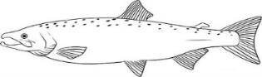

2007

2008

2009

2010

2011

2012

Age-3

Age-4

Age-5



2013

4

3

5



2014

3

4

5



2015

3

4

5

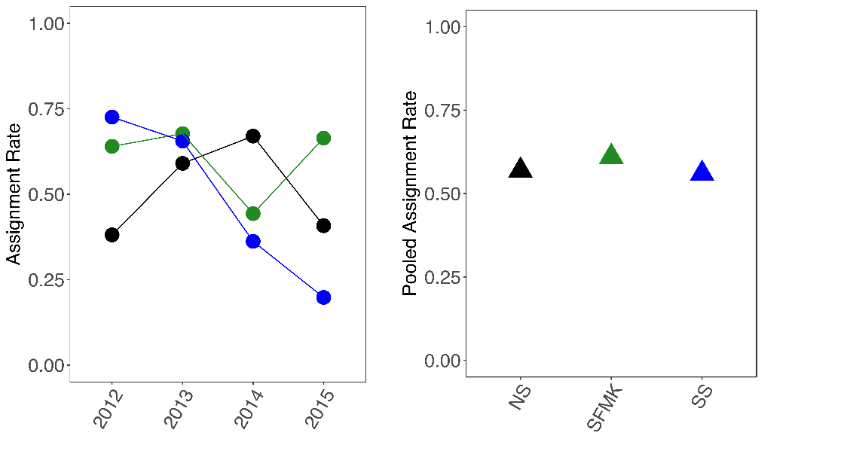

**Figure 3.** The proportion of assigned adult spring Chinook salmon returns within each of the three sub-basins (NS; black, SFMK; green, SS; blue) on an annual basis (circles) and pooled across all years (triangles).

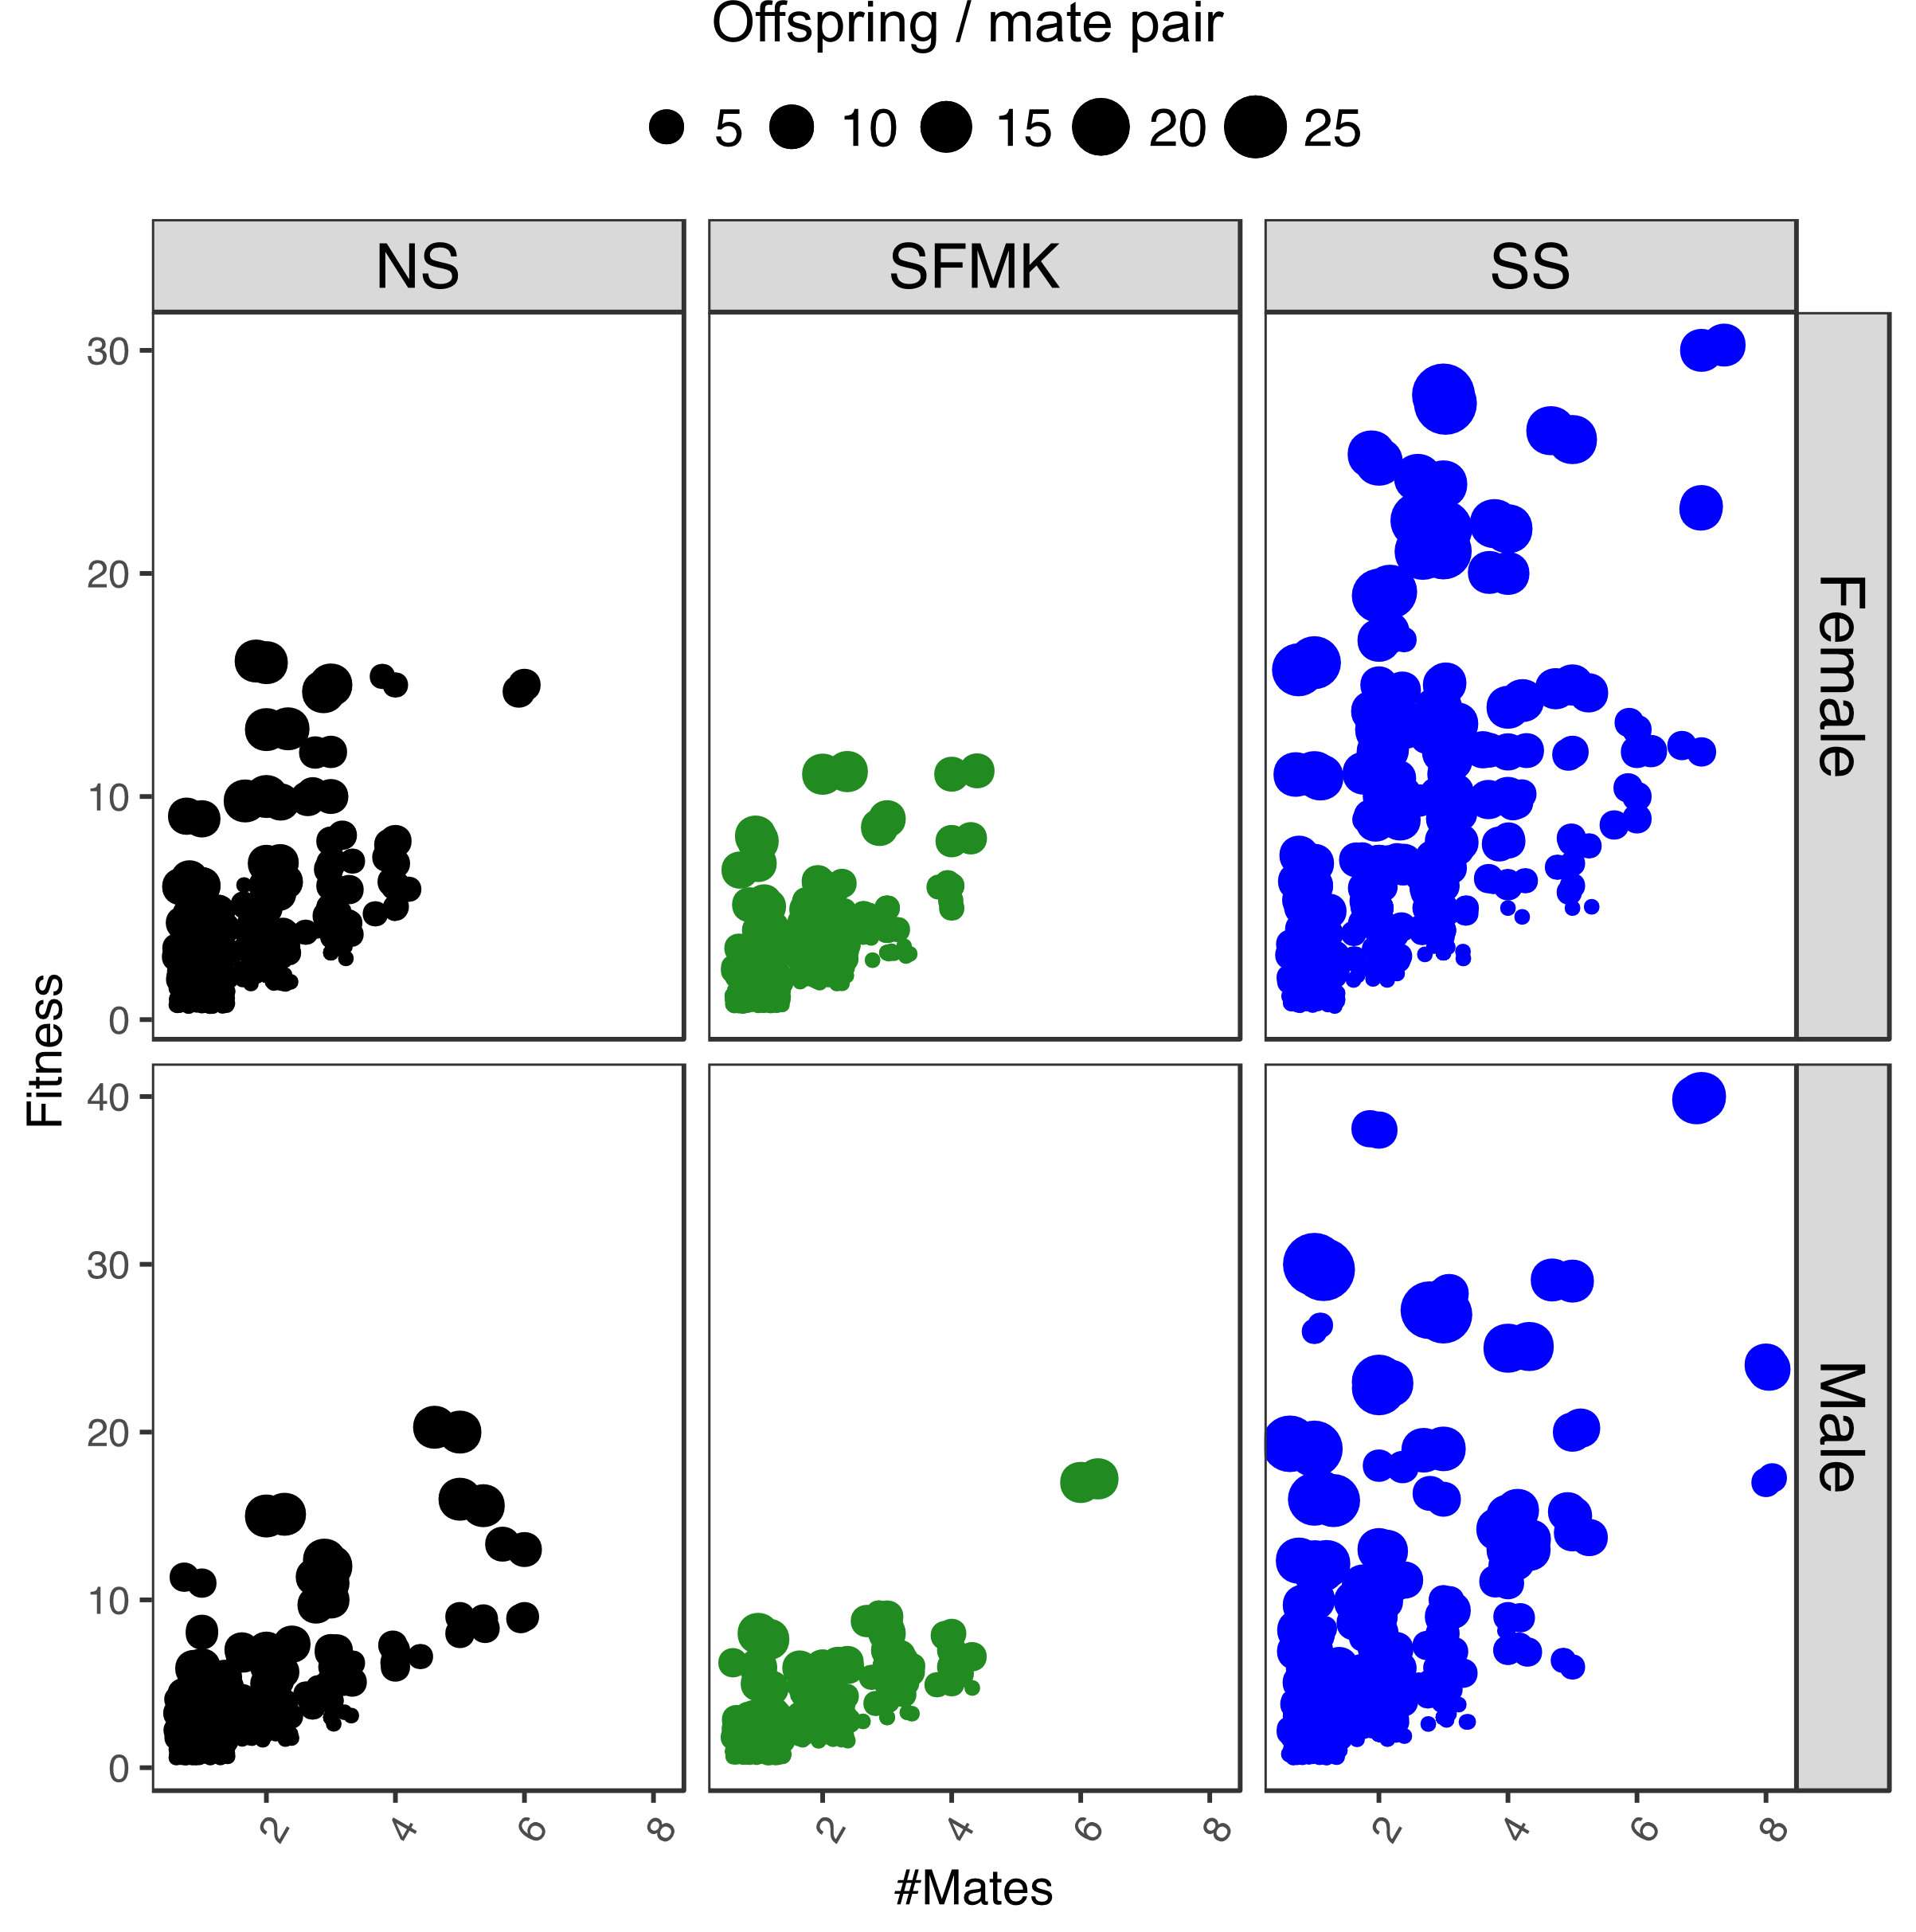

**Figure 4.** The relationship between total lifetime fitness and the number of mates for spring Chinook salmon reintroduced above high-head dams on North Santiam (NS; black), the South Fork McKenzie (SFMK; green), and the South Santiam (SS; blue) Rivers. Total lifetime fitness (Y-axis) is defined by the number of age 3-5 progeny assigned to individual salmon. Number of mates (X-axis) were identified by examining the number of different mates within trios (progeny assigned a mom and dad). Individuals are factored by sub-basin (NS, SFMK, SS) and sex (Female, Male), with point size corresponding to the greatest number of offspring observed for each individual (across its mate pairs).

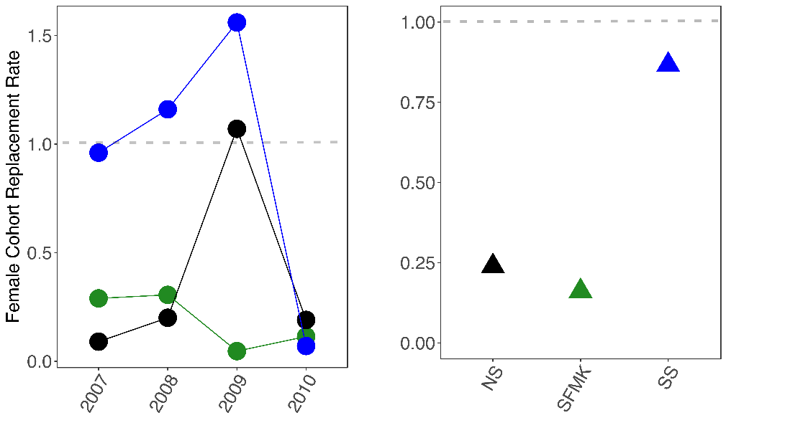

**Figure 5.** Female cohort replacement rate for adult spring Chinook salmon reintroduced above high-head dams on each of the three sub-basins (NS; black, SFMK; green, SS; blue) on an annual basis (circles) and pooled across all years (triangles).

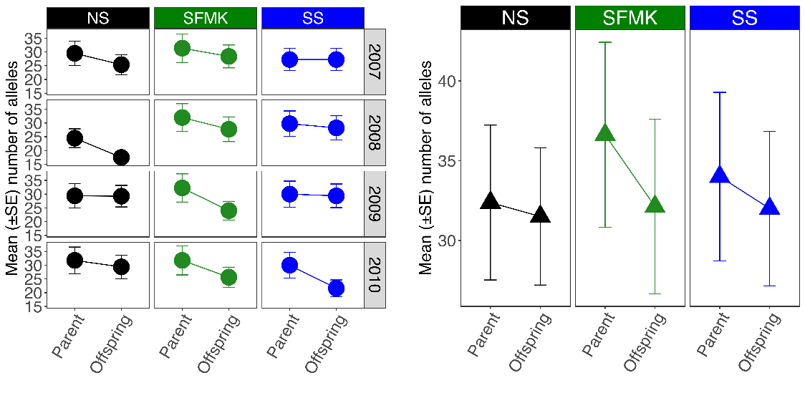

**Figure 6.** The mean (+/- SE) number of alleles observed between parents and assigned progeny within each of the three sub-basins (NS; black, SFMK; green, SS; blue) on an annual basis (circles) and pooled across all years (triangles).

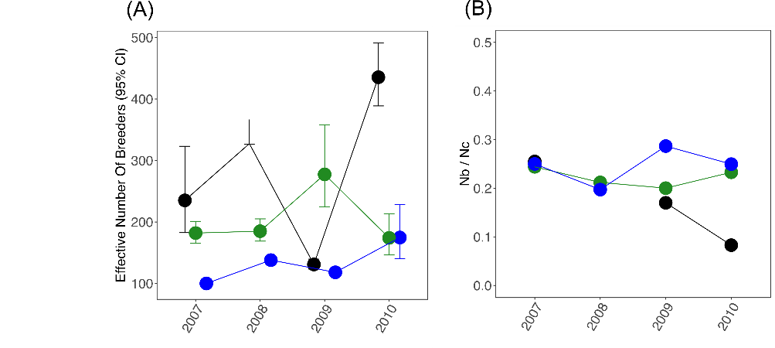

**Figure 7.** The effective number of breeders (*Nb* +/- 95% CI) for each reintroduction year (A) and the ratio between Nb and Nc (census size; B) during 2007 – 2010 for each of the three sub-basins (NS; black, SFMK; green, SS; blue) on an annual basis (A) and pooled across all years (B).

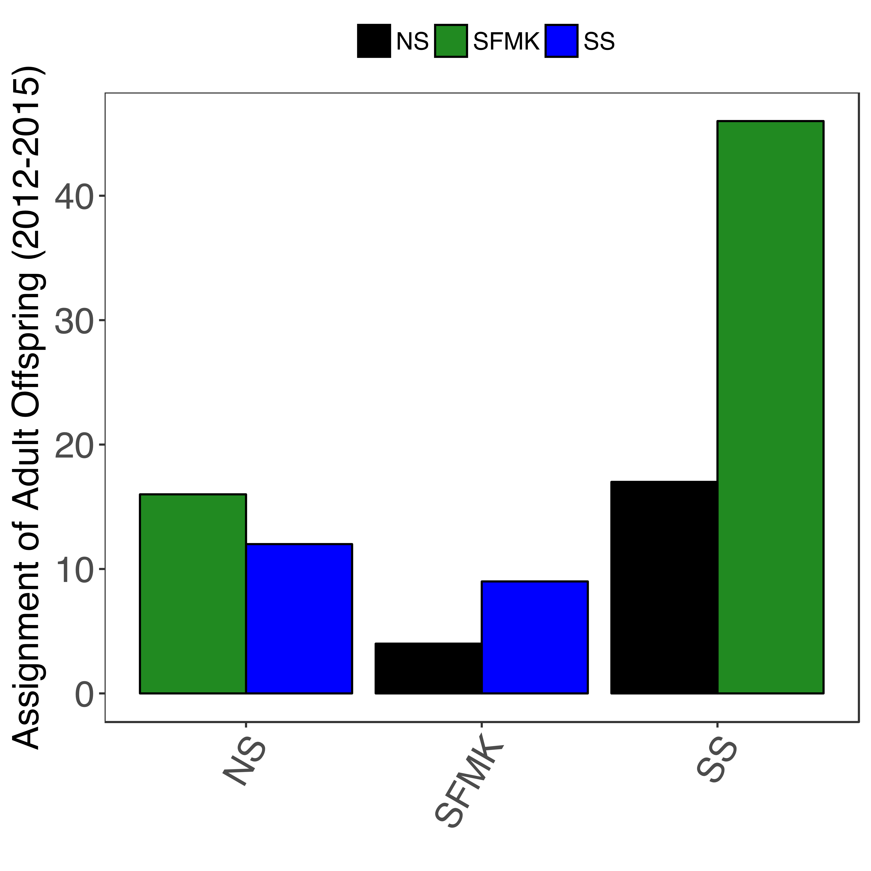

**Figure 8.** Stray spring Chinook salmon identified among the three sub-basins using genetic parentage analysis of shared loci (*N* =8). Overall, 2813 salmon that were previously unassigned were included for analysis as adult offspring and compared to the multi-locus genotypes of putative parents from the three sub-basins. The number of offspring (*N* = 104) that assigned to a parent(s) from a different sub-basins are illustrated above, with the color of the bar corresponding to the sub-basin it assigned to and the x-axis corresponding to the location of the trap-and-transport facility that it was sampled.